==================================================

Running Genetic Algorithm with LightGBM...

==================================================

==================================================

=== GENETIC ALGORITHM OPTIMIZATION ===

==================================================

[Initialization]

- Population size: 30

- Generations: 20

- Crossover rate: 80%

- Mutation rate: 20%

- Search space: 14 features

- Target: Minimize MSE using LightGBM

==================================================

=== OPTIMIZATION RESULTS ===

==================================================

▶ Best MSE achieved: 0.490991

▶ Time elapsed: 434.48 seconds

▶ Features selected: 14/14 (0.0% reduction)

▶ Selected features:

1. 0

2. 1

3. 2

4. 3

5. 4

6. 5

7. 6

8. 7

9. 8

10. 9

11. 10

12. 11

13. 12

14. 13

▶ Convergence progress:

- Initial MSE: 0.4951

- Final MSE: 0.4910

- Improvement: 0.8%

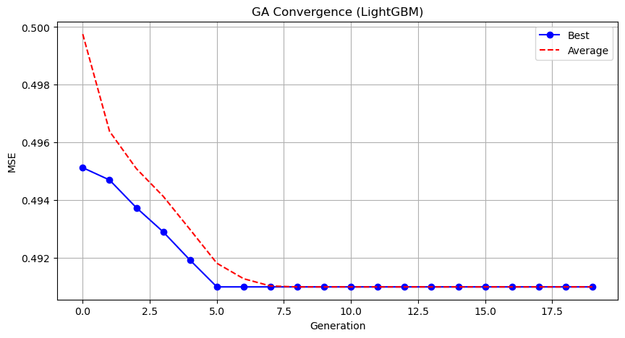

Genetic Algorithm completed successfully with MSE: 0.4910

==================================================

Running Particle Swarm Optimization with LightGBM...

==================================================

==================================================

=== PARTICLE SWARM OPTIMIZATION ===

==================================================

[Initialization]

- Swarm size: 30 particles

- Iterations: 20

- Cognitive weight: 0.5

- Social weight: 0.5

- Inertia weight: 0.5

- Search space: 14 features

- Target: Minimize MSE using LightGBM

==================================================

=== OPTIMIZATION RESULTS ===

==================================================

▶ Best MSE achieved: 0.490991

▶ Time elapsed: 470.19 seconds

▶ Features selected: 14/14 (0.0% reduction)

▶ Selected features (with weights):

1. 0 (weight: 0.536)

2. 1 (weight: 0.535)

3. 2 (weight: 0.501)

4. 3 (weight: 0.842)

5. 4 (weight: 0.660)

6. 5 (weight: 0.613)

7. 6 (weight: 0.560)

8. 7 (weight: 0.502)

9. 8 (weight: 0.707)

10. 9 (weight: 0.558)

11. 10 (weight: 0.833)

12. 11 (weight: 0.897)

13. 12 (weight: 0.866)

14. 13 (weight: 0.954)

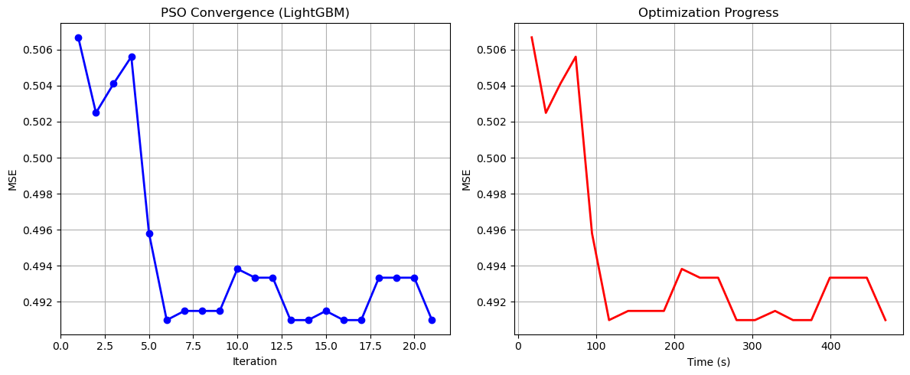

Particle Swarm Optimization completed successfully with MSE: 0.4910

==================================================

Running Whale Optimization with LightGBM...

==================================================

==================================================

=== WHALE OPTIMIZATION ALGORITHM ===

==================================================

[Initialization]

- Population: 30 whales

- Max iterations: 20

- Spiral coefficient (b): 1.0

- Search space: 14 features

- Target: Minimize MSE using LightGBM

==================================================

=== OPTIMIZATION RESULTS ===

==================================================

▶ Best MSE achieved: 0.490991

▶ Time elapsed: 477.74 seconds

▶ Features selected: 14/14 (0.0% reduction)

▶ Selected features:

1. 0

2. 1

3. 2

4. 3

5. 4

6. 5

7. 6

8. 7

9. 8

10. 9

11. 10

12. 11

13. 12

14. 13

▶ Convergence progress:

- Initial MSE: inf

- Final MSE: 0.4910

- Improvement: nan%

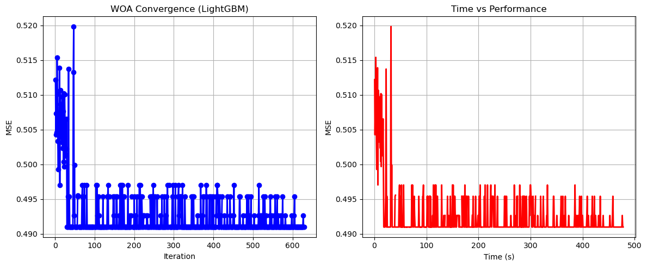

Whale Optimization completed successfully with MSE: 0.4910

==================================================

Running Squid Game Optimizer with LightGBM...

==================================================

==================================================

=== SQUID GAME OPTIMIZER (SGO) ===

==================================================

[Initialization]

- Players: 30 (15 offensive, 15 defensive)

- Max games: 20

- Search space: 14 features

- Target: Minimize MSE using LightGBM

==================================================

=== OPTIMIZATION RESULTS ===

==================================================

▶ Best MSE achieved: 0.493343

▶ Time elapsed: 419.50 seconds

▶ Features selected: 13/14 (7.1% reduction)

▶ Selected features:

1. 0

2. 1

3. 3

4. 4

5. 5

6. 6

7. 7

8. 8

9. 9

10. 10

11. 11

12. 12

13. 13

▶ Convergence progress:

- Initial MSE: 0.4955

- Final MSE: 0.4933

- Improvement: 0.4%

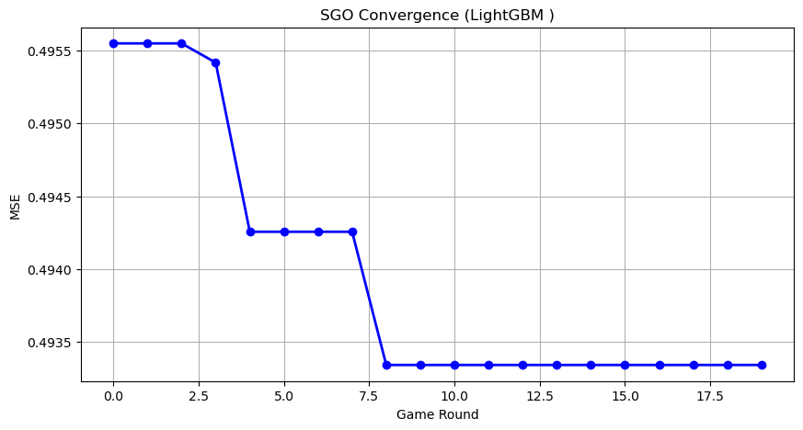

Squid Game Optimizer completed successfully with MSE: 0.4933

==================================================

Running PSH-Hyptrite with LightGBM...

==================================================

==================================================

=== PSH-HYPTRITE OPTIMIZATION ===

==================================================

[Initialization]

- Search points: 30

- Max iterations: 20

- Initial radius: 0.5 (adaptive)

- Hypersphere samples: 3 per point

- Search space: 14 features

- Target: Minimize MSE using LightGBM

==================================================

=== OPTIMIZATION RESULTS ===

==================================================

▶ Best MSE achieved: 0.490991

▶ Time elapsed: 1397.41 seconds

▶ Features selected: 14/14 (0.0% reduction)

▶ Selected features (with weights):

1. 0 (weight: 0.708)

2. 1 (weight: 0.799)

3. 2 (weight: 0.803)

4. 3 (weight: 0.566)

5. 4 (weight: 0.527)

6. 5 (weight: 0.833)

7. 6 (weight: 0.829)

8. 7 (weight: 1.000)

9. 8 (weight: 0.991)

10. 9 (weight: 0.971)

11. 10 (weight: 0.618)

12. 11 (weight: 0.988)

13. 12 (weight: 1.000)

14. 13 (weight: 0.553)

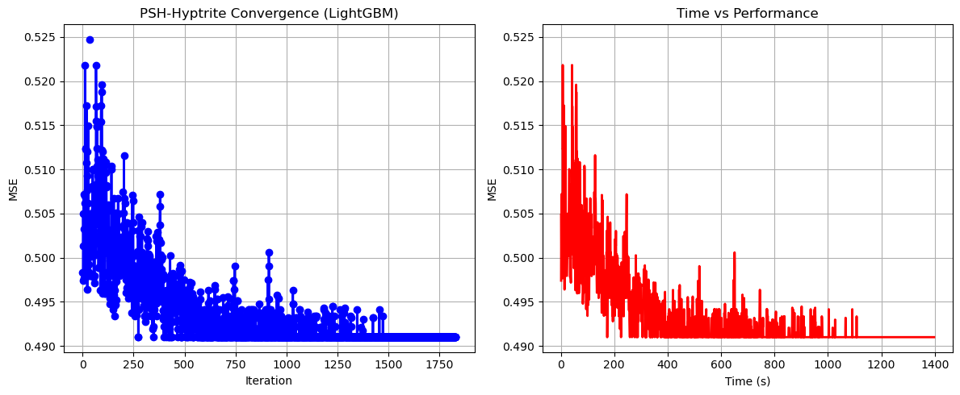

PSH-Hyptrite completed successfully with MSE: 0.4910

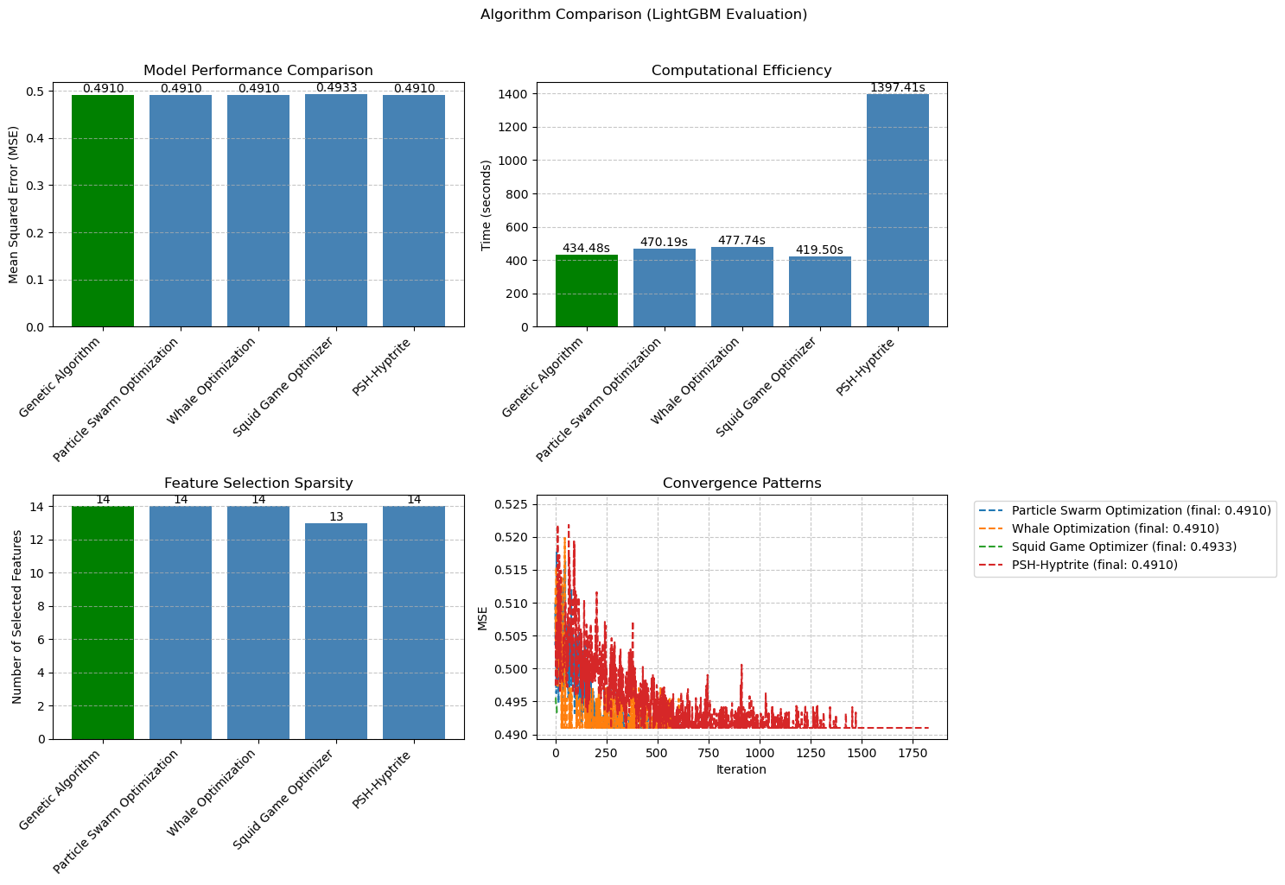

============================================================

=== FINAL FEATURE SELECTION RESULTS USING LightGBM ===

============================================================

🏆 BEST ALGORITHM: GENETIC ALGORITHM

• MSE: 0.490991

• Time: 434.48 seconds

• Features: 14/14 (0.0% reduction)

📊 COMPARISON TABLE:

Algorithm MSE Time (s) Features

---------------------------------------------------------------------------

Genetic Algorithm 0.490991 434.48 14

Particle Swarm Optimization 0.490991 470.19 14

Whale Optimization 0.490991 477.74 14

PSH-Hyptrite 0.490991 1397.41 14

Squid Game Optimizer 0.493343 419.50 13

🔍 SELECTED FEATURES:

1. 0

2. 1

3. 2

4. 3

5. 4

6. 5

7. 6

8. 7

9. 8

10. 9

11. 10

12. 11

13. 12

14. 13

💡 Tip: Consider feature importance from LightGBM for further analy